Conditional Programming: if –else, switch-case

If(condition🡺 true)

{

// if trues this block works

}

Else

{

// else this block works

}

Condition : to write we use operators

Arithmetic operators**:+,-,*,/,%**

/ it gives quotient

%- modulo- its gives reminder

Relational operators: **>,<,>=,<=,==,!=**

**Logcal operators: and=>&&**

**Or=>||**

**And table Or table**

**T t =>t t t =>t**

**T f =>f t f =>t**

**F t =>f f t =>t**

**F f =>f f f =>f**

**Increment/decrement operators: pre and post**

**T=x++ 🡺 pre increment 🡺t =x,x=x+1**

**Example: t=2;x=4;t=x;t=4**

**X=5**

**Post inrement 🡺 t=++x;**

**X=x+1;t=x;**

**Ex: t=4,x=5;**

**X=6,t=6**

**Invisible_number=34;**

**Invisible_number=invisible_number+5;🡺invisible_number+=5**

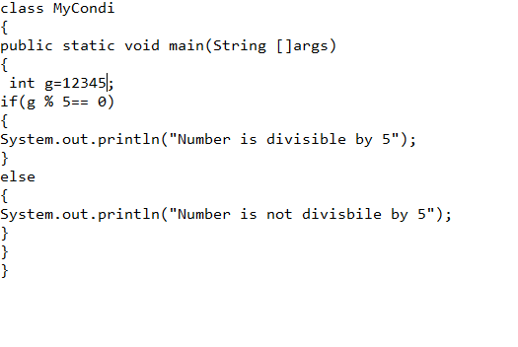

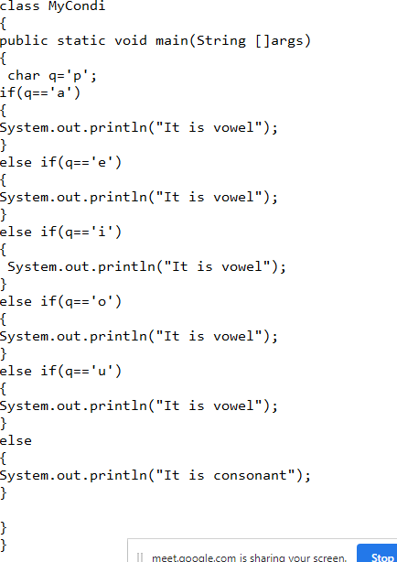

**Logical operators:**

